**Basic Granola Recipe**

*By* [*Roxanne Webber*](http://www.chow.com/search?q=Roxanne%20Webber&c%5b%5d=recipes)

Difficulty: [Easy](http://www.chow.com/recipes/category/easy) | Total Time: 40 mins | Makes:About 3 cups

Granola is basically toasted oats. It’s incredibly easy to buy for exorbitant prices, yet incredibly easy to make at home. Here is a basic granola base to which you can add whatever dried fruit, nuts, or other tasty bits make you happy. Feel free to tweak this recipe if you like other spices, a little less honey, more salt—it’s pretty forgiving, and customizing your own blend is fun.

**What to buy:** If you want to experiment even more, try using other rolled grains such as [rye](http://www.chow.com/recipes/30066), [spelt](http://www.chow.com/recipes/30063), [kamut](http://www.chow.com/recipes/30065), or [barley](http://www.chow.com/recipes/30064) instead of rolled oats.

INGREDIENTS

* 3 cups rolled oats (not instant)
* 3 tablespoons packed light brown sugar
* 1/2 teaspoon ground cinnamon
* 1/4 teaspoon kosher salt
* 1/3 cup honey
* 1/4 cup vegetable oil
* 1 teaspoon vanilla extract
* 1/2 cup small-dice dried fruit
* 1/2 cup coarsely chopped raw or toasted nuts or seeds

INSTRUCTIONS

1. Heat the oven to 300°F and arrange a rack in the middle.
2. Place the oats, brown sugar, cinnamon, and salt in a large bowl and stir to combine; set aside.   
   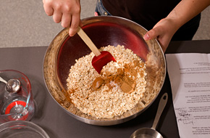
3. Place the honey, oil, and vanilla in a small bowl and stir to combine. Pour over the oat mixture and mix until the oats are thoroughly coated.   
   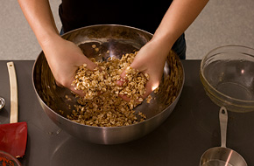
4. Spread the mixture in a thin, even layer on a rimmed baking sheet. Bake for 15 minutes, then stir and continue baking until the granola is very light golden brown, about 5 to 15 minutes more.   
   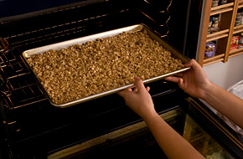
5. Place the baking sheet on a wire rack and cool the granola to room temperature, stirring occasionally, about 20 minutes. (Note: It will harden as it cools.)   
   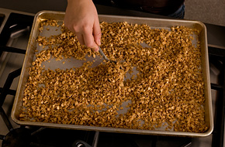
6. Add the fruit and nuts or seeds to the baking sheet and toss to combine. Store the granola in an airtight container for up to 2 weeks.   
   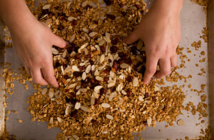

SOURCE: http://www.chow.com/recipes/30062-basic-granola

Copyright ©2012 CBS Interactive. All Rights Reserved